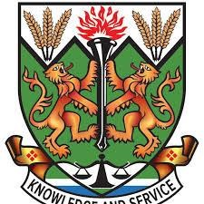**NJALA UNIVERSITY**

**NJALA CAMPUS**

**SCHOOL: SCHOOL OF AGRICULTUTRE AND FOOD SCIENCIES**

**PROGRAM: HIGHER DIPLOMA IN AGRICULTURE GENERAL (AGRONOMY)**

**YEAR: ONE (1)**

**MODULE: COMMUNICATION SKILLS**

**TOPIC: PRONOUN**

**NAME: MAGRET CONTEH**

**TUTOR: MR IBRAHIM .M. FOFANAH**

**TERM PAPER**